AGRICULTURAL PRODUCTION

OPTIMIZATION ENGINE

### A Project Work Synopsis

*Submitted in the partial fulfillment for the award of the degree of*

# BACHELOR OF ENGINEERING

# IN

### ARTIFICIAL INTELLIGENCE

### &

### MACHINE LEARNING

### Submitted by:

### NAME OF THE STUDENT

### ARYAN KUSHWAHA (20BCS6691)

**ANKITH RAJ (20BCS6684)**

**VAIBHAV SINGH (20BCS3842)**

### Under the Supervision of:

### SUPERVISORS NAME

**AMIT GARG**



### CHANDIGARH UNIVERSITY, GHARUAN, MOHALI - 140413,

**PUNJAB**

#### MONTH & YEAR

#### 25th February 2022

#### i

***Annexure-4* (A typical specimen of table of contents)**

# Table of Contents

|  |  |
| --- | --- |
| Title Page  Declaration of the Student Abstract Acknowledgement  List of Figures  List of Tables (optional) Timeline / Gantt Chart | i |
| ii |
| iii |
| iv |
| v |
| vi |
|  |

#### INTRODUCTION\* 1

* 1. Problem Definition 1
  2. Project Overview/Specifications\* (page-1 and 3) 2
  3. Hardware Specification 3
  4. Software Specification 4

1.3.1 4

1.3.2

…

1. LITERATURE SURVEY 5
   1. Existing System 5
   2. Proposed System 6

7

1. [PROBLEM FORMULATION](#_TOC_250001) 8
2. RESEARCH OBJECTIVES 9
3. [METHODOLOGY 10](#_TOC_250000)

#### TENTATIVE CHAPTER PLAN FOR THE PROPOSED WORK 11

#### RESULT & DISCUSSION 12-20

1. **REFERENCES 21-22**
2. **APPENDICES**

**ABSTRACT**

E-agriculture is the integration of technology and digital mechanisms into agricultural processes for more efficient output. This study provided a machine learning–aided mobile system for farmland optimization, using various inputs such as location, crop type, soil type, soil pH, and spacing. Random forest algorithm and BigML were employed to analyze and classify datasets containing crop features that generated subclasses based on random crop feature parameters. The subclasses were further grouped into three main classes to match the crops using data from the companion crops. The study concluded that the approach aided decision making and also assisted in the design of a mobile application using Appery.io. This Appery.io then took in some user input parameters, thereby offering various optimization sets. It was also deduced that the system led to users’ optimization of information when implemented on their farmlands.

***ii***

## DECLARATION

I, **Ankith Raj**, student of **‘Bachelor of Engineering in Artificial Intelligence and Machine Learning**, **session: 2020-2024** , Department of Computer Science and Engineering, Apex Institute of Technology, Chandigarh University, Punjab, hereby declare that the work presented in this Project Work entitled ‘**Agriculture Production Optimization Engine’** is the outcome of our own bona fide work and is correct to the best of our knowledge and this work has been undertaken taking care of Engineering Ethics. It contains no material previously published or written by another person nor material which has been accepted for the award of any other degree or diploma of the university or other institute of higher learning, except where due acknowledgment has been made in the text.

**Date:14 July 2021**

**Place: Chandigarh**

**iii**

**Name:** **Ankith Raj**

**Candidate UID: 20BCS6684**

**ACKNOWLEDGEMENT**

**The Success and eventual result of this project involved a lot of support and help from a lot of individuals, and I am immensely grateful to have accomplished this during the culmination of my project work. Whatever I have done is because of help and assistance, and I will never forgot to thank them.**

**I appreciate and thank Mrs. Akwinder kaur for giving me the chance to do project work in Rishi System and for giving us all the support and advice that made me complete the project on time. I am immensely grateful to her for having such strong encouragement and directions even through she was busy .**

**I owe my sincere gratitude to our project guide Monika Singh, who took a keen interest in our project work and led us all among until the end of our project work by providing all the requisite Knowledge for the implementation of successful method.**

**I warmly thank our internal project guide Mrs Monika Singh Department of Computer Science for his advice and feedback on this project and motivation and more timely assistance and advice before the end our of our project work.**

**I am grateful and lucky enough to receive consistent motivation, assistance, and advice from all the employees of the department of informatics who have helped us to complete our project work. I would also like to extend our heartfelt respects to all the non-teaching employees of the computer science department for their timely assistance.**

***iv***

## List of Figures

##### Figure Title page

|  |  |  |
| --- | --- | --- |
| **Fig 6.1** | **Average Ratio of the component** | **12** |
| **Fig 6.2** | **Statistics of N ,P,K, Humdity , Ph and rainfall** | **13** |
| **Fig 6.3** | **Average , Maximum and minimum** | **13** |
| **Fig 6.4** | **Average value of component in different crops** | **14** |
| **Fig 6.5** | **Which crop require more than average component** | **14** |
| **Fig 6.6** | **Graph** | **14** |
| **Fig 6.7** | **Interesting fact of crops** | **15** |
| **Fig 6.8**  **Fig 6.9**  **Fig6.10**  **Fig6.11**  **Fig6.12**  **Fig6.13**  **Fig6.14** | **In which season which crop is suitable to grow**  **The Elbow Method**  **KMeans Clustering**  **Table**  **Confusion Matrix for logistics Regression**  **Which crop is good and conditions to know**  **Crops prediction based upon given input** | **15** |

**v**

## List of Symbols

*Symbol Description*

***Ast Asc Asv b d d’***

***fc,ave fsc***

##### fy Sv xu

***~~x~~***

*τ* ***c***

*Area of steel reinforcement bars on tension face*

*Area Of steel reinforcement bars on compression face Area of two legs of the closed stirrups*

*Breadth of rectangular beam section Effective depth of rectangular beam section Effective cover on compression face Average compressive stress in concrete Stress in steel on the compression side*

*Characteristic strength of steel reinforcement bars Spacing of the stirrups*

*Depth of neutral axis from compression face*

*Depth of centroid of the compression block in concrete Shear strength offered by concrete*

vi

# INTRODUCTION

#### Agriculture is vital for the development of the world. We, humans, benefit from agriculture one way or the other, which has made agriculture a key area of study. Farmers will always need information to refer to, most especially when growing crops that are not common in their land or culture and average farmer has access to crude sources of information such as TV, radio, newspapers, fellow farmers, government agricultural agencies, farm supply, and traders and there is, therefore, a need for a system that allows farmers access to relevant information.

#### As we all know that agriculture depends largely on the nature of soil and the climatic conditions and the nature of soil and the climatic conditions and many a times, we face unpredictable changes in climate like , non-seasonal rainfall or heat waves or fluctuations in humidity levels, etc. and all such events cause a great loss to our farmers and farming, because of which they are not able to utilize their agricultural land to it’s fullest. So to solve all such problems, I ahave build a Machine Learning Model by the virtue of which we can help farmers, optimize the agricultural production, because this predictive model will help them understand that for a particular soil and given climate condition, which crop will be best suitable for the harvest.

#### Machine learning is among the trending technologies; hence, there exist several technologies and systems that run on a machine learning framework . In recent times, several machine learning systems in agriculture have been tested and created. Research of several machine learning algorithms’ effectiveness in agriculture and other application domains has also been conducted and this is because machine learning is a very effective tool for efficient use of resources, prediction, and management, which are needed in agriculture. Machine learning is the ability of an electrical processing system to acquire knowledge and apply that knowledge.

#### The scope of this work is concerned with food crop agriculture and using machine learning to help optimize land for maximal crop yield by efficiently utilizing land resources. Crop yield relies strongly on how effectively the basic land requirements can be utilized; land here refers to topography, soil type, soil nutrients, water content, sunlight, and all such factors related to crop growth on farmable areas.

#### There are 7 key factors that we have taken into account which will help us in determining , exactly which crop should be grown and at what period of time, viz. Amount of Nitrogen, Phosphorous and potassium in soil , Temperature in degree celcius , Humidity, pH and rainfall in mm.

#### 1

## Project OverView/Specifications.

The Agriculture Production Optimization engine thee scope of this work is concerned with food crop agriculture and using machine learning to help optimize land for maximal crop yield by efficiently utilizing land resources. Crop yield relies strongly on how effectively the basic land requirements can be utilized; land here refers to topography, soil type, soil nutrients, water content, sunlight, and all such factors related to crop growth on farmable areas.

## This Project helps in maintaining the database of the students in any educational organization. We can easily access any students information anytime and can be kept safely for long period of time without any damage.

## Field efficiency defined as a rate of agricultural machine performance during field operations is calculated from the ratio between the real field productivity and the theoretical maximum productivity of the machine. Field efficiency depends on several factors. Thus, it is not constant for a particular agricultural machine. Among others, these factors include the size and shape of the field, crop yield and moisture. However, the most important factor is the pattern of field operation, which significantly affects time lost during non-working travel in the field.

**2**

## HardWare Specifications

**The hardware required for the development of the project is:**

* + - **Processor:** Intel P-IV System
    - **Processor Speed:** 250 MHz to 833 MHz
    - **Ram:** 512 Mb Ram
    - **Hard Disk:** 40 Gb

**3**

* 1. **Software specifications**

1. **Jupyter Notebbok**
2. **Python(3.0.3**

#### 4

# LITERATURE REVIEW

# Physical optimization has been key to increasing the productivity and efficiency of agricultural machinery for decades. This is related to the savings resulting from the improved mechanical functionality of the machines. Currently, there are environmental and biological factors that prevent further developments in the field of mechanical optimization. In particular, it is a matter of limiting the size and weight of the machines, where soil compaction machines can be mentioned as an example [1]. Analysis of the planned operation, operations optimization focusing on the route optimization and capacity dimensioning, as well as operation planning (including resource allocation, scheduling, analysis of the time required to carry out the operation and mission planning) are integral parts of modern agricultural operations management which supplement traditional agricultural operations planning methods. Considering the current development of automation systems using communication and information technologies, it is possible that human sensory and mental inputs could be replaced by such systems. The use of these automation systems provides a number of emerging benefits, including increased repeatability associated with increased work performance and increased capacity. In addition, labor costs and the use of material inputs (e.g., agrochemicals and fertilizers) decrease. Moreover, the flexibility of the production system increases due to the easier adoption of new production practices. Automation systems also provide better control of processes, leading to the increased quality of products

## Existing System

Through From the Agriculture Production Optimization Engine the Farmers able to find the solution either to grow which crop and what are the possibilities so they check these possibilities and harvest on that product.

Students will able to learn from these mini project how farmers suffer and can able to create some new inventions for farmers so life becomes easy for farmers also.

5

**2.2 Proposed System**

By developing the system we can attain the following features:

* + - Easy to handle and feasible
    - Cost Reduction
    - Fast and Convenient

**2.3 Feasibility Study:**

Feasibility Study begins when a problem is identified by managers and users of department. In this phase, the systems analyst visits the relevant department and starts preliminary investigations.

Objectives of Feasibility Study: The main objectives of feasibility study are:

▪ To identify the deficiencies in the current system.

▪ To determine objectives of the proposed system.

▪ To acquire a sense of scope of the system.

▪ To identify the responsible users.

▪ To determine whether it is feasible to develop the new system. Steps in Feasibility Study: Feasibility study is carried out in the following steps:

▪ Form a project team and appoint a project leader (Systems Analyst).

▪ Start preliminary investigation through different fact finding techniques.

▪ Prepare the systems flowcharts of the current system.

▪ Identify and describe the deficiencies in the current system.

▪ Determine objectives of the proposed system.

▪ Prepare the systems flowchart of the proposed system.

▪ Identify and enumerate the existing computer systems along with their technical specifications.

▪ Determine the cost and benefits of the proposed system.

**6**

▪ Identify the responsible users and determine the operational feasibility.

▪ Prepare the feasibility study report.

▪ Give the oral presentation of the feasibility study.

## Types of Feasibility :

1. **Technical Feasibility:** During this study, the analyst identifies the existing computer systems of the concerned department and determines whether these technical resources are sufficient for the proposed system or not. If they are not sufficient, the analyst suggests the configuration of the computer systems that are required. The analyst generally pursues two or three different configurations which satisfy the key technical requirements but which represent different costs. During technical feasibility study, financial resources and budget is also considered. The main objective of technical feasibility is to determine whether the project is technically feasible or not, provided it is economically feasible.
2. **Economic Feasibility:** Economic Feasibility the most important study that determines the cost and benefits of the proposed system and compares with the budget. The cost of the project should not outweigh the budget. The cost of the project includes the cost of hardware, software, development and implementation. Cost/benefit analysis is the common method to determine the benefits that are expected from the proposed system and compare them with the costs expected to spend on development of the system.
3. **Operational Feasibility:** When it is found that the project is both economic and technical feasible, the next step is to detemine whether it is operationally feasible or not. During operational feasibility study, it is operationally feasible or not, During operational feasibility study, it is determined whether the system will operate in the way that user wants or not. Operational feasibility depends upon human resources for the development and implementation of the system. It is considered whether the qualified or experienced manpower is available for development and implementation of the system or not. User involvement is more required in determining the operational feasibility.

7

### Literature Review Summary

Table 2.1: Literature review summary

|  |  |  |  |  |  |  |  |  |
| --- | --- | --- | --- | --- | --- | --- | --- | --- |
| **Year and citation** | **Article Title** | **Purpose of the study** | **Tools/ Software used** | **Type of**  **vulnerabilities** | **Source (Journal/ Conference)** | **Findings** | **Data set (if used)** | **Evaluation parameters** |
| 2010 | Agriculture Production optimization Engine | In Agriculture Production Optimization Engine is to build a predictive model so as to suggest the most suitable Crops to grow based on the available Climate and soil Conditions.  There are 7 key factors that I have taken into account which will help us in determining exactly which crop should be grown and at what period of time, viz. Amount of nitrogen, phosphorous and potassium etc. | Python & Jupyter Notebook libraries used:  Pandas , Seaborn , Matplotlib , ipywidgets and sklearn.  Machine Learning Algorithms used: Clustering Analysis and Logistic Regression. | This project helps to reduce the time management and helps the farmers to manage the details of crop for long period of time which is a solution forfarmers.  There is a vast details of crops to manage and keep it safe so there is a application of program that keep this details safe. | As we seen in many newspaper and TV’s how farmers suffer from this problems.  Dataset is available in many websites. | We find which crop should be grown and at what period of time, viz. Amount of nitrogen, phosphorous and potassium in soil , Temperature in degree Celsius , humidity , pH and rainfall in mm | The data set which I take reference are here:  <https://www.kaggle.com/devsharma5/agricultural-production-optimization-engine> | In this Agriculture Production Optimization Engine Mini project I had used some of the modules in this program to run the program .  The libraries that I used are:   1. Numpy 2. Pandas 3. Matplotlib 4. Sklearn 5. Ipywidgets   The Machine Learning Algorithms used here are   1. Clustering 2. LogisticRegression |

# PROBLEM FORMULATION

During software development, clones can occur in software intentionally or unintentionally. Developers tend to clone fragments of software during development to save efforts and expedite the development process.

From the literature review, it is observed that studies highlight the need of efficient and scalable approach for detecting code clones having software vulnerability. The existing techniques are not able to detect all types of vulnerable code clones. Different approaches suffer from high false negative rate and not scalable to large software systems due to high time complexity. So firstly, there is a need Second same subject systems should be used to compare the approaches which detect

* The problem occurred before having computerized system includes:
* File lost When computerized system is not implemented file is always lost because of human environment. due to some human error there may be a loss of records.
* File damaged when a computerized system is not there file is always lost due to some accident like of water by some member on file accidentally. Besides some natural disaster like floods or fires may also damage the files.
* Difficult to search record When there is no computerized system there is always a difficulty in searching of records if the records are large in number.
* Space consuming
* After the number of records become large the space for physical storage of file and records also if no computerized system is implemented.
* Cost consuming As there is no computerized system to add each record paper will be needed which will increase the cost the management of library.

8

# OBJECTIVES

The proposed work is aimed to carry out work leading to the development of an approach for agriculture production optimization engine. The proposed aim will be achieved by dividing the work into following objectives:

1. To understand and explore various types of libraries and algorithms existing in open source software
2. To study and analyze various dataset and perform various functions on the data set.
3. To design and develop the technique for agriculture production.
4. To verify and validate the proposed system.

An individual corporation bodies or even a nation we are confronted with a lot of problems everybody such as relaxing to education technology, physiology and psychological aspect of life.

In order to solve these problems, we have to make a strong decision as to methods and steps of solving the various problems. To be able to make a headway we need to conduct research.

Therefore, research is considered as the process of arriving at a dependable solution to a given problem through the systematic collection, analysis and interpretation of data.

The research objective of “Agriculture Production Optimization Engine ” is to allow the farmers to know the problems in below ways.

1. In which season the crop is suitable to grow with following conditions.
2. Like what temperature , humidity and pH level are required to grow.
3. Farmers can know that the temperature is changing so they can change the crops growth and start the next crop which is suitable.
4. So it would help farmers and even the normal people cn know for their knowledge so they can grow in their farms.

9

# METHODOLOGY

The following methodology will be followed to achieve the objectives defined for proposed research work:

1. Detailed study of software vulnerabilities, their types and impact of code cloning practice on software vulnerabilities will be done.

2. Installation of clone detection tools and hand on experience on existing approaches of clone detection applicable for software code clone vulnerability will be done. Relative pros and cons will be identified.

3. Vulnerability database will be created, which corresponds to the python open source projects that have some vulnerabilities according to National Vulnerability Database (NVD) [36] and Open Sourced Vulnerability Database (OSVDB) [51].

4. Different clone detections techniques will be analysed to figure it out which clone detection technique is appropriate for particular type of vulnerability.

5. An approach will be developed for vulnerable code clone detection.

6. Various parameters will be identified to evaluate the proposed system.

7. Comparison of new implemented approach with exiting approaches will be done..

10

1. **TENTATIVE CHAPTER PLAN FOR THE PROPOSED WORK**

#### CHAPTER 1: INTRODUCTION

#### This chapter will cover the overview of Agriculture problems faced by farmers by this the farmers are able to know. As we all know that agriculture depends largely on the nature of soil and the climatic conditions and the nature of soil and the climatic conditions and many a times, we face unpredictable changes in climate like , non-seasonal rainfall or heat waves or fluctuations in humidity levels, etc. and all such events cause a great loss to our farmers and farming, because of which they are not able to utilize their agricultural land to it’s fullest. So to solve all such problems, I ahave build a Machine Learning Model by the virtue of which we can help farmers, optimize the agricultural production, because this predictive model will help them understand that for a particular soil and given climate condition, which crop will be best suitable for the harvest.

#### CHAPTER 2: LITERATURE REVIEW

This chapter include the literature available for findings of the researchers will be highlighted which will become basis of current implementation. From this we can know the crops suitable and we know the tool suded in this mini project.

#### CHAPTER 2: BACKGROUND OF PROPOSED METHOD

This chapter will provide introduction to the concepts which are necessary to understand the proposed system. From we learn clustering analysis and logistic Regression and some of function from which we can compare and know the perfect solution.

#### CHAPTER 4: METHODOLOGY

This chapter will cover the technical details of the proposed approach.

1. Detailed study of software vulnerabilities, their types and impact of code cloning practice on software vulnerabilities will be done.

2. Installation of clone detection tools and hand on experience on existing approaches of clone detection applicable for software code clone vulnerability will be done. Relative pros and cons will be identified.

3. Vulnerability database will be created, which corresponds to the python open source projects that have some vulnerabilities according to National Vulnerability Database (NVD) [36] and Open Sourced Vulnerability Database (OSVDB) [51].

4. Different clone detections techniques will be analysed to figure it out which clone detection technique is appropriate for particular type of vulnerability.

5. An approach will be developed for vulnerable code clone detection.

6. Various parameters will be identified to evaluate the proposed system.

7. Comparison of new implemented approach with exiting approaches will be done..

11

#### CHAPTER 5: EXPERIMENTAL SETUP

This chapter will provide information about the subject system and tools used for evaluation of proposed method.

Here software used is :

1.Jupyter Notebook

2. Python.

Libraries like:

1. Numpy
2. Pandas
3. Matplotlib
4. Sklearn
5. Ipywidgets.

Machine Learning algorithms:

1. Clustering Analysis.
2. Logistic Regression.

#### CHAPTER 6: RESULTS AND DISCUSSION:

#### WE can know the average ratio of particular Component:

#### 

#### Fig 6.1

#### 12

#### We can find the statistics in terms of N , P , K, Temp , Humidity , PH and Rainfall

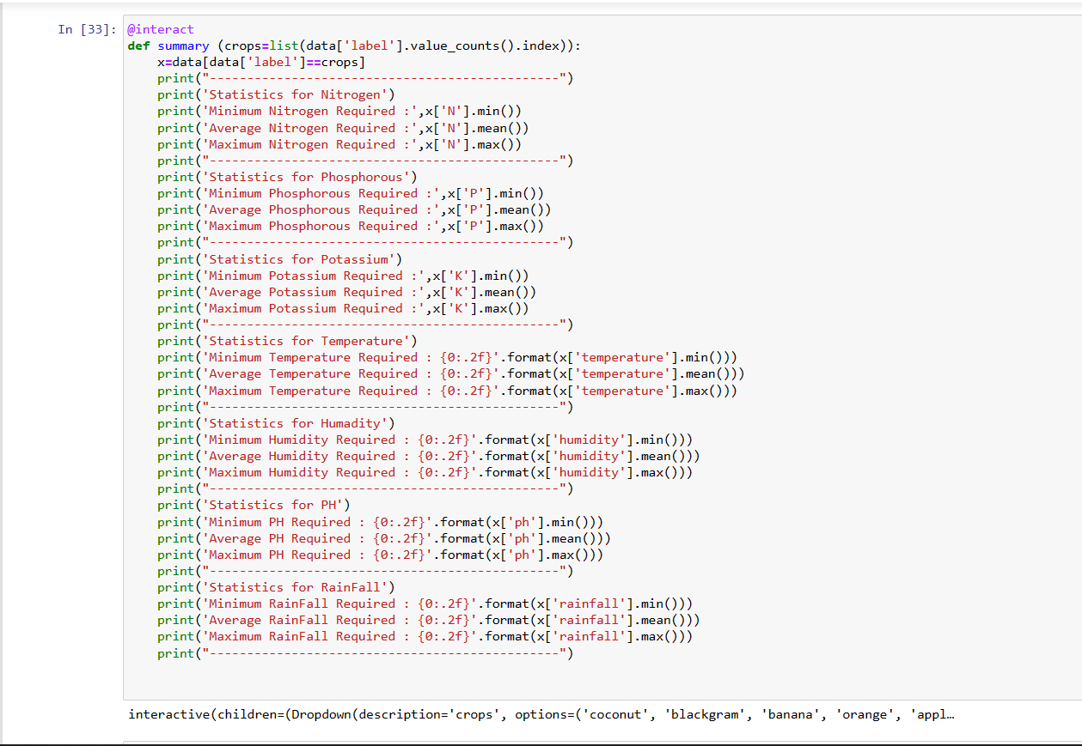

**Fig 6.2**

We can able to find average , minimum and maximum.

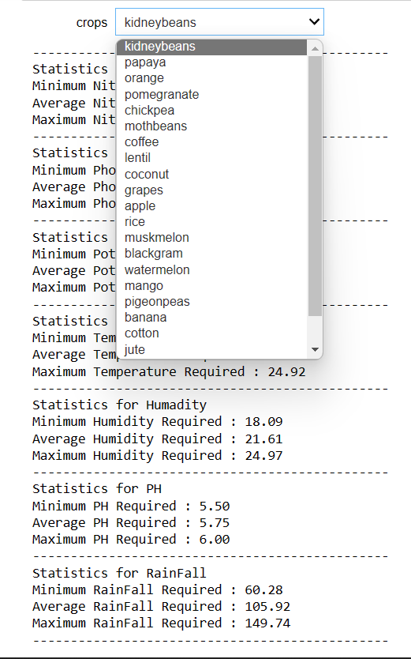

Fig 6.3

13

**Averge value of nitrogen in different crops:**

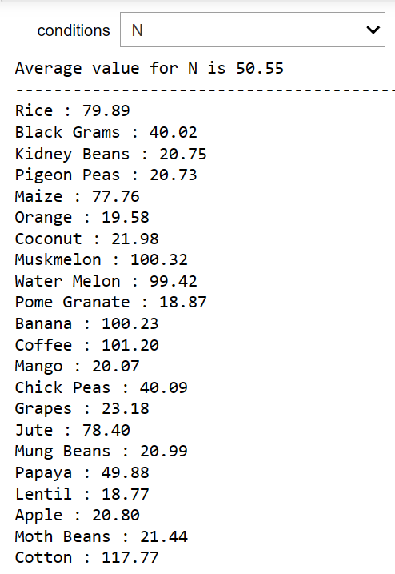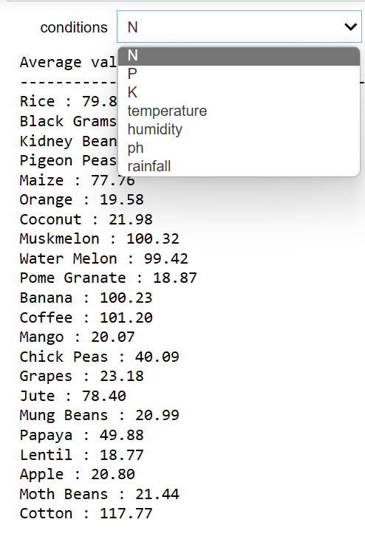

Fig 6.4

14

**Crops which require more than average component or temp or humiduty to grow which crop:**

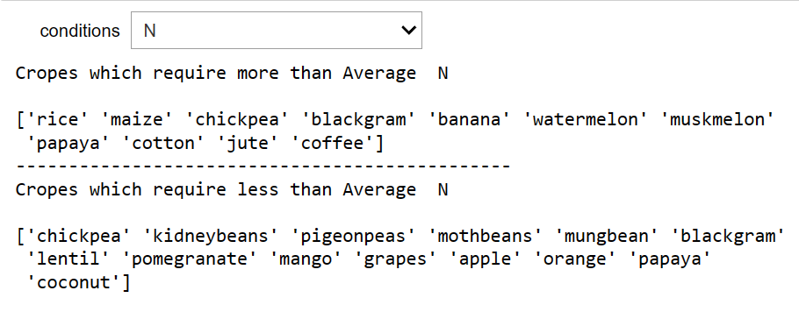

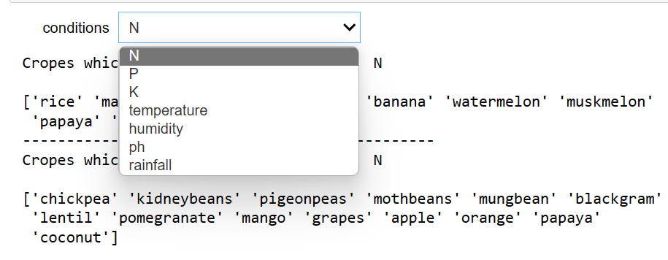

Fig 6.5

**Graph in Temperature in density and humidity:**

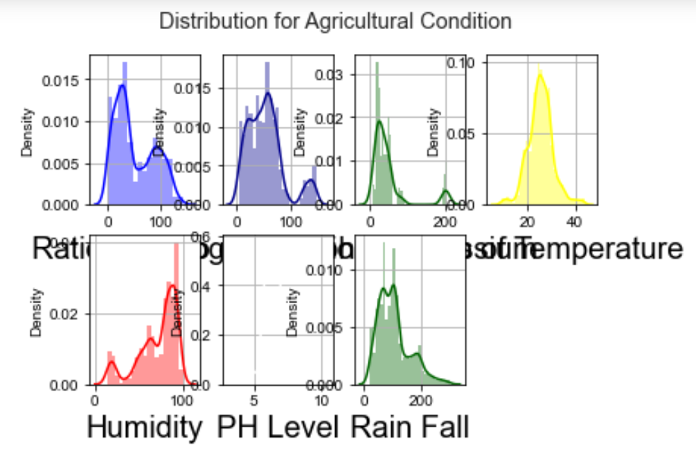

Fig6.6

15

Interesting facts of crops:

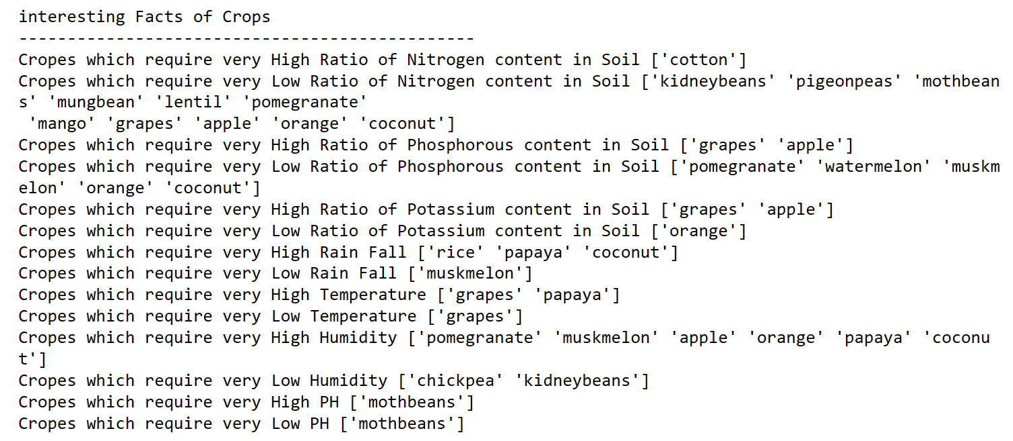

Fig 6.7

**We can know which crop is suitable to grow in which season:**

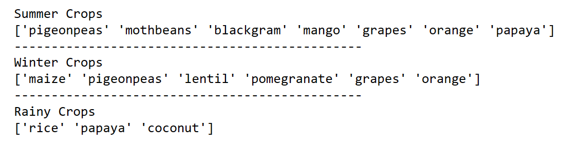

Fig 6.8

The Elbow method:

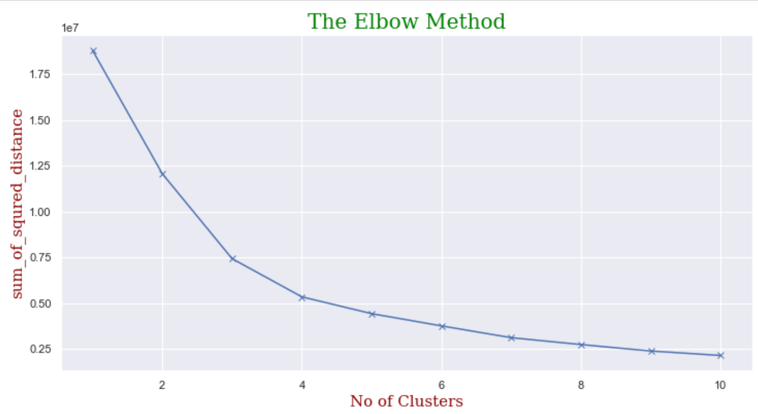

**Fig 6.9**

**16**

**We csn apply Kmeans Clustering Anlysis in which cluster:**

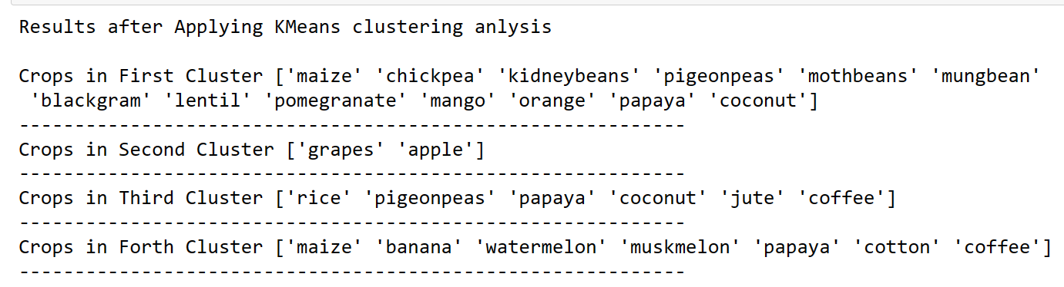

Fig 6.10

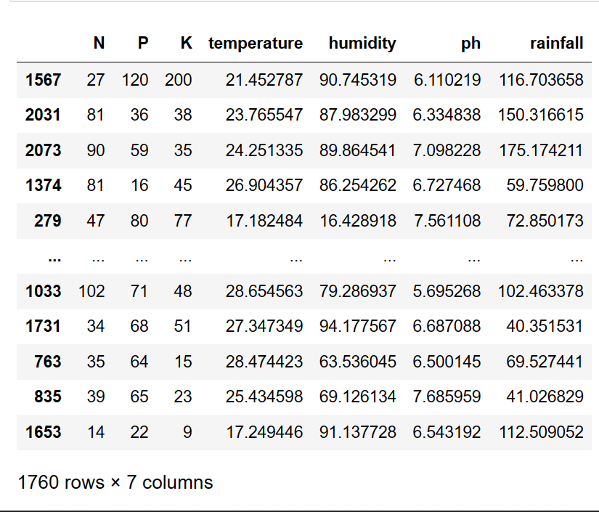

Fig 6.11

17

**Confusion Matrix For Logistic Regression:**

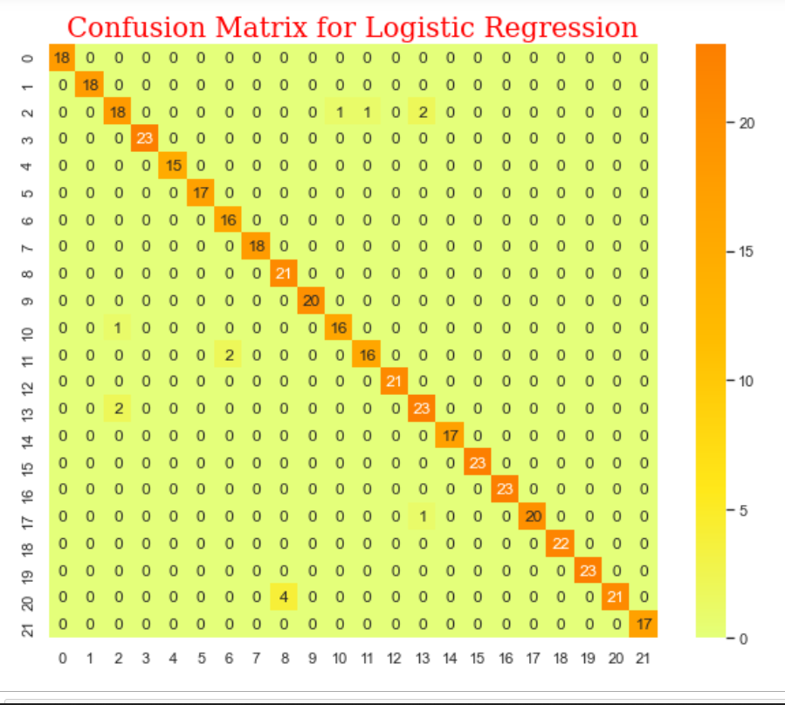

Fig 6.12

18

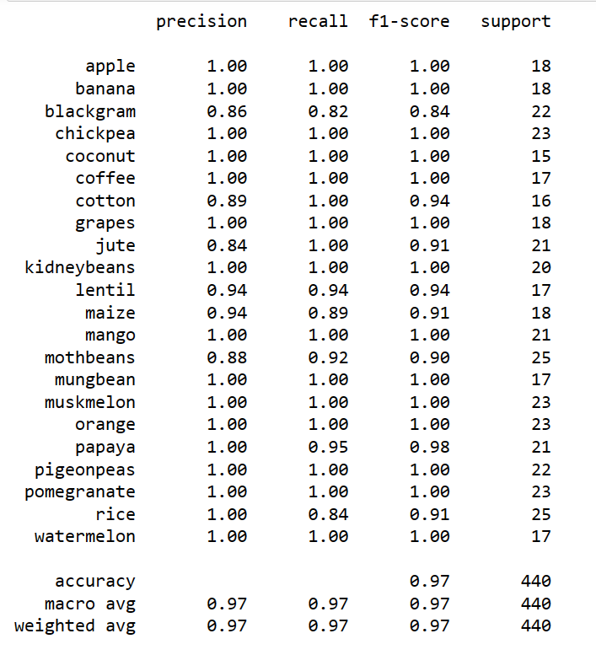

Fig 6.13

19

**As last we can predict by taking input and know the crop: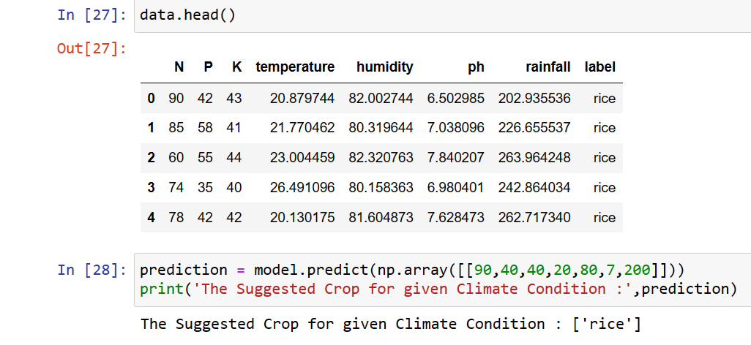**

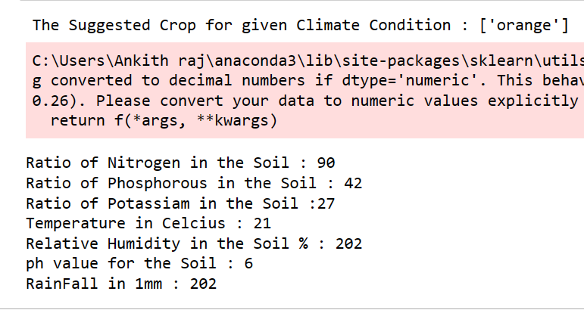

Fig 6.14

20

The result of proposed technique will be discussed in this chapter.

#### CHAPTER 7: CONCLUSION AND FUTURE SCOPE

**CONCLUSION:**

Most farmers do not have access to a central repository of relevant information that will help them make full use of and optimize their farmland. &is work provided a mobile application interface that allows farmers to access their farmland information and guarantees them the services they need instantly.

FUTURE SCOPE:

In future work, the machine learning models used to inform parameter setting in the mobile application could be developed using the machine learning algorithm embedded in the system and used to predict.

#### PUBLICATIONS (Optional)

# REFERENCES

1. C. Miller, V. N. Saroja, and C. Linder, *ICT Uses for Inclusive Agricultural Value Chains*, Food and agriculture organization of the united nations (FAO), Rome, Italy, 2013.
2. K. Liakos, P. Busato, D. Moshou, S. Pearson, and D. Bochtis, “Machine learning in agriculture: a review,” *Sensors*, vol. 18, no. 8, p. 2674, 2018.View at: [Publisher Site](https://doi.org/10.3390/s18082674" \t "_blank) | [Google Scholar](https://scholar.google.com/scholar_lookup?title=Machine%20learning%20in%20agriculture:%20a%20review&author=K.%20Liakos&author=P.%20Busato&author=D.%20Moshou&author=S.%20Pearson&author=&author=D.%20Bochtis&publication_year=2018" \t "_blank)
3. P. Priya, U. Muthaiah, and M. Balamurugan, “Predicting yield of the crop using machine learning algorithm,” *International Journal of Engineering Sciences & Research Technology*, vol. 7, pp. 1–7, 2018.View at: [Google Scholar](https://scholar.google.com/scholar_lookup?title=Predicting%20yield%20of%20the%20crop%20using%20machine%20learning%20algorithm&author=P.%20Priya&author=U.%20Muthaiah&author=&author=M.%20Balamurugan&publication_year=2018" \t "_blank)
4. J. H. Jeong, J. P. Resop, N. D. Mueller et al., “Random forests for global and regional crop yield predictions,” *PLoS One*, vol. 11, no. 6, Article ID e0156571, 2016.View at: [Publisher Site](https://doi.org/10.1371/journal.pone.0156571" \t "_blank) | [Google Scholar](https://scholar.google.com/scholar_lookup?title=Random%20forests%20for%20global%20and%20regional%20crop%20yield%20predictions&author=J.%20H.%20Jeong&author=J.%20P.%20Resop&author=N.%20D.%20Mueller%20et%20al.&publication_year=2016" \t "_blank)
5. D. Ming, T. Zhou, M. Wang, and T. Tan, “Land cover classification using random forest with genetic algorithm-based parameter optimization,” *Journal of Applied Remote Sensing*, vol. 10, Article ID 35021, 2016, [http://remotesensing.spiedigitallibrary.org/](http://remotesensing.spiedigitallibrary.org/" \t "_blank).View at: [Google Scholar](https://scholar.google.com/scholar_lookup?title=Land%20cover%20classification%20using%20random%20forest%20with%20genetic%20algorithm-based%20parameter%20optimization&author=D.%20Ming&author=T.%20Zhou&author=M.%20Wang&author=&author=T.%20Tan" \t "_blank)
6. I. Nitze, U. Schulthess, and H. Asche, “Comparison of machine learning algorithms random forest artificial neural network and support vector machine to maximum likelihood for supervised crop yield classification,” in *Proceedings of the 4th GEOBIA*, pp. 35–40, Salzburg Austria, May 2012.View at: [Google Scholar](https://scholar.google.com/scholar_lookup?title=Comparison%20of%20machine%20learning%20algorithms%20random%20forest%20artificial%20neural%20network%20and%20support%20vector%20machine%20to%20maximum%20likelihood%20for%20supervised%20crop%20yield%20classification&author=I.%20Nitze&author=U.%20Schulthess&author=&author=H.%20Asche" \t "_blank)

21

1. X. Chen and P. Cournede, “Model-driven and data-driven approaches for crop yield prediction: analysis and comparison,” *International Scholarly and Scientific Research & Innovation*, vol. 11, no. 7, pp. 334–342, 2017.View at: [Google Scholar](https://scholar.google.com/scholar_lookup?title=Model-driven%20and%20data-driven%20approaches%20for%20crop%20yield%20prediction:%20analysis%20and%20comparison&author=X.%20Chen%20&author=P.%20Cournede&publication_year=2017" \t "_blank)
2. P. Mitra, A. Mukherjee, and A. Chandra, “Machine learning for prediction of crop yield: a case study on rain-fed area rice yield from West Bengal, India,” in *Proceedings of the DSANRM2017: Workshop on Data Science for Agriculture and Natural Resource Management*, International Institute of Information Technology (IIIT, Hyderabad), December 2017.View at: [Google Scholar](https://scholar.google.com/scholar_lookup?title=Machine%20learning%20for%20prediction%20of%20crop%20yield:%20a%20case%20study%20on%20rain-fed%20area%20rice%20yield%20from%20West%20Bengal,%20India&author=P.%20Mitra&author=A.%20Mukherjee&author=&author=A.%20Chandra" \t "_blank)

**22**